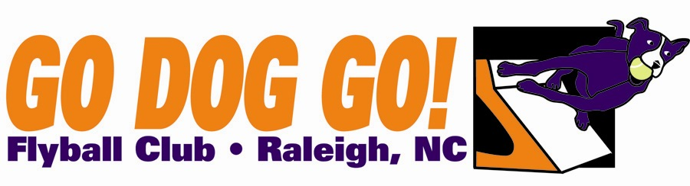
Veterans $60 per team
Go Dog Go! Flyball Club
Two one-day tournaments
June 8-9 2013
Durham Kennel Club
Hillsborough, NC
Regular, Open, Multi $75 per team
eamay Close date: May 7, 2013
49 ft. minimum runback
Judges : Kyle Mankes

FMI: Contact Nadine at nadine.mcbride@gmail.com or 919-414-9051

Make checks payable to: Go Dog Go! Flyball Club
Mail entries to: 5108 Elf Court Wake Forest, NC 27587

Club Name:
Name: Phone:
Address:
E-mail address:

Team Name Type Seed Time
1). Reg MB Vets Open
2). Reg MB Vets Open
3). Reg MB Vets Open 4). Reg MB Vets Open
5). Reg MB Vets Open

Titles our club expects to receive:

