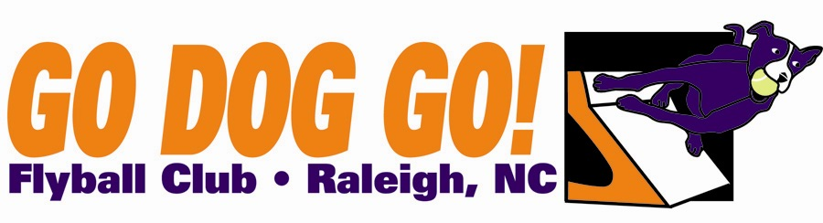
Veterans $120 per team
Go Dog Go! Flyball Club
One two-day tournament
July 21-22 2011
Duplin Event Center
Duplin NC
Regular, Open, Multi $170 per team
eamay Close date: June 20, 2012
60 ft. minimum runback
Judges : Kyle Mankes, Geoff Brown

FMI: Contact Nadine at nadine.mcbride@gmail.com or 919-414-9051

Make checks payable to: Go Dog Go! Flyball Club
Mail entries to: 5108 Elf Court Wake Forest, NC 27587

Club Name:
Name: Phone:
Address:
E-mail address:

Team Name Type Seed Time
1). Reg MB Vets Open
2). Reg MB Vets Open
3). Reg MB Vets Open 4). Reg MB Vets Open
5). Reg MB Vets Open

Titles our club expects to receive:

