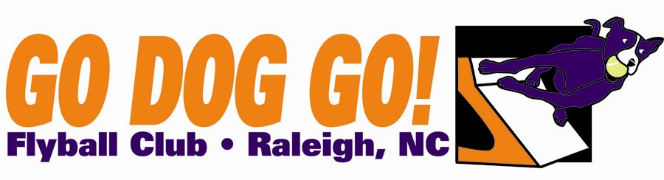
Go Dog Go! Flyball Club
Two one-day tournaments
March 21 2009
March 22 2009
Durham Kennel Club
Durham NC
Veterans $60 per team per day
Regular and Multibreed $75 per team
per day Close date: February 20, 2009
50 ft. runback
Judge : Leerie Jenkins

Limited to 12 Regular, 6 Multibreed, 4 Vets
FMI: Contact Nadine at nadine.mcbride@gmail.com or 919-414-9051

Make checks payable to: Go Dog Go! Flyball Club
Mail entries to: 5108 Elf Court Wake Forest, NC 27587

Club Name:
Name: Phone:
Address:
E-mail address:

Saturday March 21, 2009
Team Name Type Seed Time
1). Reg MB Vets 2). Reg MB Vets 3). Reg MB Vets 4). Reg MB Vets
5). Reg MB Vets

Sunday March 22, 2009
Team Name Type Seed Time
1). Reg MB Vets 2). Reg MB Vets 3). Reg MB Vets 4). Reg MB Vets
5). Reg MB Vets

