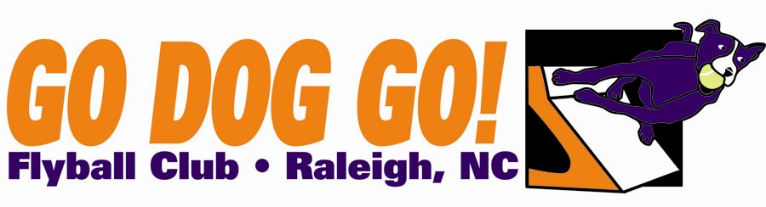
Go Dog Go! Flyball Club
One two-day tournament
March 20-21 2010
Wilson Fairgrounds
Wilson NC
Veterans $120 per team
Regular, Open, Multibreed $150 per team
per day Close date: February 22, 2010
60 ft. minimum runback
Judge : Kyle Mankes

Limited to 10 Regular, 10 Open, 8 Multibreed, 4 Vets
FMI: Contact Nadine at nadine.mcbride@gmail.com or 919-414-9051

Make checks payable to: Go Dog Go! Flyball Club
Mail entries to: 5108 Elf Court Wake Forest, NC 27587

Club Name:
Name: Phone:
Address:
E-mail address:

Team Name Type Seed Time
1). Reg MB Vets Open
2). Reg MB Vets Open
3). Reg MB Vets Open 4). Reg MB Vets Open
5). Reg MB Vets Open

