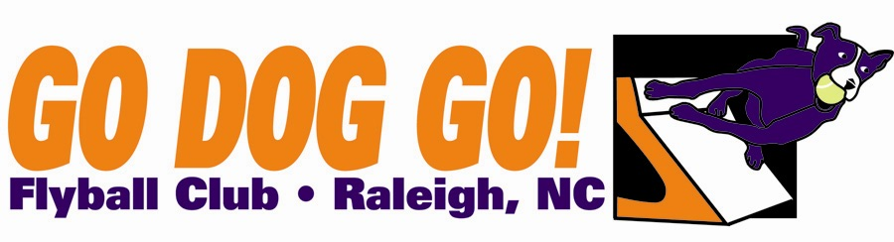
Go Dog Go! Flyball Club
One two-day tournaments
August 17-18 2013
Herbert C. Young Community Center
Cary, NC
Veterans $130 per team
Regular, Open, Multi $180 per team
eamay Close date: July 10, 2013
60 ft. minimum runback
Judges : Kyle Mankes

FMI: Contact Nadine at nadine.mcbride@gmail.com or 919-414-9051

Make checks payable to: Go Dog Go! Flyball Club
Mail entries to: 5108 Elf Court Wake Forest, NC 27587

Club Name:
Name: Phone:
Address:
E-mail address:

Team Name Type Seed Time
1). Reg MB Vets Open
2). Reg MB Vets Open
3). Reg MB Vets Open 4). Reg MB Vets Open
5). Reg MB Vets Open

Titles our club expects to receive:

