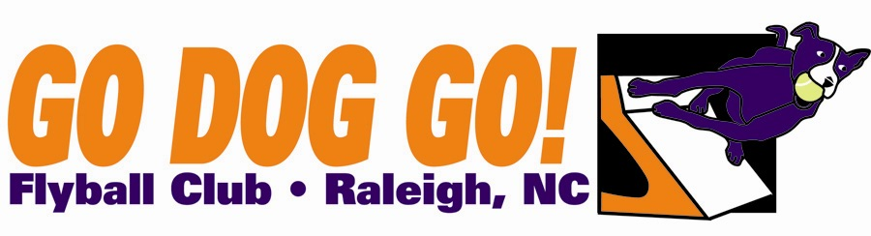
Go Dog Go! Flyball Club
One two-day tournament
August 16-17 2014
Herbert C. Young Community Center
Cary, NC
Veterans $135 per team
Regular, Open, Multi $185 per team
eamay Close date: July 9, 2014
60 ft. minimum runback
Judges : Kyle Mankes, Amy Brubaker

FMI: Contact Nadine at nadine.mcbride@gmail.com or 919-414-9051

Make checks payable to: Go Dog Go! Flyball Club
Mail entries to: 5108 Elf Court Wake Forest, NC 27587

Club Name:
Name: Phone:
Address:
E-mail address:

Team Name Type Seed Time
1). Reg MB Vets Open
2). Reg MB Vets Open
3). Reg MB Vets Open 4). Reg MB Vets Open
5). Reg MB Vets Open

Titles our club expects to receive:

