***Go Dog Go! Flyball Club***

***One two-day tournament limited to 20 Regular, 4 Multi, 4 Open***

***August 9-10, 2025***

***Quicksilver Canine***

***Julian, NC***

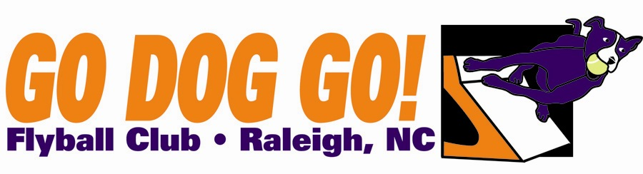

Regular, Open, Multi $250 per team

eamay Close date: June 23, 2025

70 ft. minimum runback

Judge: Jon Bescher

FMI: Contact Sheila McHugh at 3sportsdawgs@gmail.com

Make checks payable to: Go Dog Go! Flyball Club or PayPal (FaF) paypal@godoggo.org

Mail entries to: 2604 Pleasant Union Church Rd, Raleigh, NC 27614

Club Name:

Name: Phone:

Address:

E-mail address:

Team Name Type Seed Time

1). Reg MB Vets Open

2). Reg MB Vets Open

3). Reg MB Vets Open 4). Reg MB Vets Open

5). Reg MB Vets Open

Titles our club expects to receive: